2.3 Dropleg Beluga drilling direction

The drilling device is only available completely as a set, the Dropleg Beluga is shown in the picture as a demo component and is not part of the set. The built-in drilling bushing is tuned with D=7.5mm to the required bore for the Dropleg nozzle holder. Drill through only one wall of the pipe at a time, the other side must remain undamaged.

Before drilling, hold the base plate with the Dropleg Beluga to the boom, you have the possibility to hang the Dropleg Beluga from the front or back in the base plate. However, this then requires the selection to be made from which side they drill the pipe. Take the nozzle carrier to hand, the round side with the 2 Phillips screws must look in the direction of travel. As a farmer, you know best in which zones you have to bring the PSM, position the boats at these heights. With the appropriate selection of nozzles, the penetration can be further improved.

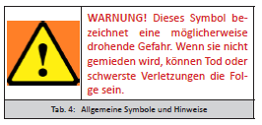

Use sharp drills and work with a stop on the drill. Remove adhering drill chips thoroughly by hand and with compressed air. Work thoroughly here, chips can later lead to blockages in the nozzles and to incorrect applications in the inventory.

7.5mm drilling bit

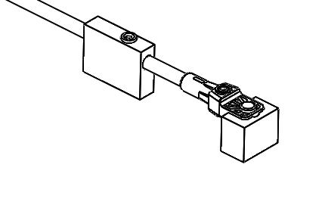
Fig. 6: Drilling device Art.Nr. 17139

2.4 Dropleg Beluga nozzle carrier

direction

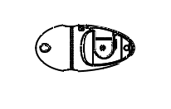

Fig. 7: The Dropleg Beluga nozzle holder Art.Nr. 16717 is available individually as an accessory or spare part. The nozzle carrier consists of front and rear part, the supplied check valve is already installed, all small parts such as seals or Phillips screws are included in the set.

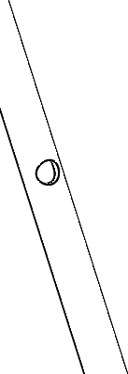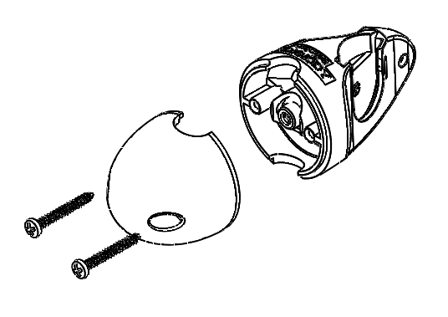

Fig. 7: Dropleg Beluga nozzle holder Art.Nr. 16717

